Conductors and Insulators
A conductor is a material through which an electric charge is readily transferred. As electricity is related to the movement of electrons, conductors tend to be materials in which there are free electrons to carry the charge. Most metals are good conductors as they have electrons that are free to travel through the material. Carbon, a non-metal, is also a conductor for this reason. Some semi-metals can also conduct electricity.

An insulator is a material through which an electric charge is not readily transferred (no free moving electrons). Good insulators are glass, mica, hard rubber, sulfur, silk, dry air and many plastics.

The Coulomb and Electric Charge
The unit of charge is called the coulomb (C). It is customary to define the coulomb (C) in terms of the ampere - the unit of electric current. Along with the kilogram, meter, and second, the ampere is to be considered the fourth fundamental unit, all other electrical units are derived units.

1 coulomb = 1 ampere second.
q = charge in coulombs (C)
I = current in amperes (A)
t = time in seconds (s)
Mathematically, we can express this as 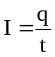 where

Example:
A microwave is used for 1.5 minutes to cook some food. If it uses 450 C of charge, what current does it draw?

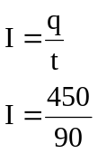t = 1.5 x 60
= 90 s

I = 5.0 A (2 sf)

Example:
A hairdryer needing a current of 6.00 A is used for 10.0 minutes, what charge flowed through the hairdryer during this time?

t = 10 x 60 q = It
= 600 s = 6.00 x 600
= 3600 C

q = 3.60 x 10³ C (3 sf)

Questions:
- Explain why metals are good conductors and why non-metals are good insulators.
When a metallic element bonds with other metals, their outer electrons are shared between all the atoms in the metallic lattice. They form a common 'sea' of delocalised electrons attached to no single atom. Because the electrons are free to move, they can carry an electrical current. In non-metals the electrons are fixed into position so unable to move a carry a charge.

- What is the function of a lightning rod on a building?
The lightning rod is attached to a thick cable that travels down the building and into the ground. The lightning rod is on the top of the building and being made of metal, is more attractive to the lightning than the building. When the lightning strikes, it travels down the cable and into the grounding leaving the building safe.
- On a dry day people often get small electric shocks when they enter or leave a car. Use your knowledge of static electricity to account for this affect.

Key idea is that the charge is caused by friction between the person’s clothes and the sea covering material. Tyres are insulating the car from the ground.

- A petrol tanker often becomes electrically charged as it drives along to its loading or unloading points.
- How does it become electricity charged?
Tanker becomes charged through friction between air and the tanker and tanker and the road. Will not escape to ground as tyres are insulators.

- Why is this dangerous?
A charged petrol tanker is dangerous as it can attain such a high electric potential that discharge (sparks) occur. This can ignite the fuel.

- What do petrol tanker manufacturers include in their design to reduce the dangers of static build-up on petrol tankers?

The greatest danger with a charged petrol tanker occurs when loading and unloading. To prevent sparking between the hoses/tanker and the ground a number of devices re used. The hoses have two special sire spirals one on the outside and one on the inside of the hose. These earth the tanker. The petrol itself has additives to increase conduction, thus increasing distribution time thus lowering the maximum electrical potential of the fuel. All hose connections are made of metal to act as additional earths. Carbon impregnated strips attached to body and trail on the ground allow current to discharge.

- Max was on coffee duty at church, and had to put out, as close together as possible, 150 empty polystyrene cups to be filled later. They were initially stacked 25 high in cartons. Suggest a reason why Max found it difficult to set them out so they stayed stable.

When taking the coffee cups out of the stacks in the carton you charge them electrically. Since polystyrene is an insulator the charge is retained and since they are set out close together there is a coulombic force between them. Whether this is attraction or repulsion makes no difference!

- A spark between your hair and your comb on a dry day moves a charge of 2.00 x 10⁻⁹ C. The spark lasts for 1.00 μs. What current flows in this case?

q = 2.00 x 10⁻⁹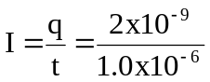 C
t = 1.0 x 10⁻⁶

I = 2.00 x 10⁻³ A (3 sf)

- A torch circuit carries a current of 325 mA for 4.50 minutes. Calculate the total charge that has left the battery in this time.

I = 0.325 A q = It
t = 4.5 x 60 = 0.325 x 270
= 270 s q = 87.8 C (3 sf)

Questions:
- A force of 1.07 x 10⁻¹ N attraction is acting on two small spheres 6.50 cm apart. If one has a charge of +10.0 nC, what is the other charge?
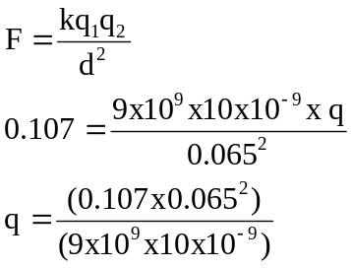
q = 5.02 x 10⁻⁶ C
But as a force of attraction, actual charge = -5.02 x 10⁻⁶ C

- How far apart are two spheres each of +5.00 μC if there is a force of 22.5 N between them?
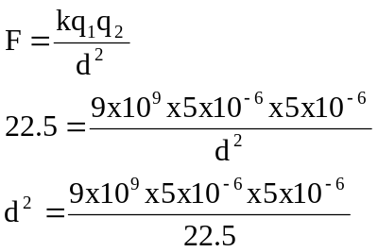
d² = 0.01
distance apart = 0.10 m
- One tiny metal ball carries a charge of +3.00 nC. A second ball, of identical size, shape and material, has a charge of -12.0 nC. The balls are 30.0 mm apart.
- What is the force of attraction between the balls?
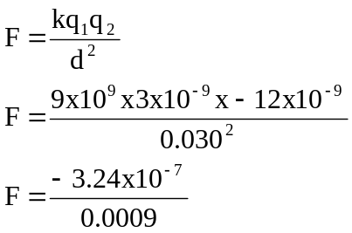
F = -3.6 x 10⁻⁴ N
F = 3.6 x 10⁻⁴ N attraction

- You make the balls touch and then separate them to 30.0 mm again. What is now the force between the balls?

+3 nC -12 nC

+3-12
= -9 nC

-4.5 nC -4.5 nC
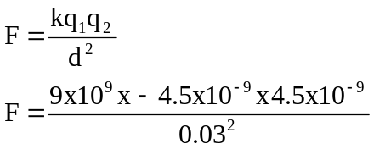

F = 2.03 x 10⁻⁴ N Repulsion

- Nick finds that his clothes are clinging together when he removes them from a clothes-drier. This results from the static charges in the clothes that built up during drying. Nick needs to exert a force of 0.500 N to pull apart two articles of clothing. Calculate the charge on each. Assuming the charges are equal and that the distance between the two articles is 0.800 mm.
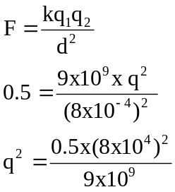
q² = 3.6 x 10⁻¹⁷ C
q = 6.0 x 10⁻⁹ C

- Two identical charges of 1.20 μC are 68.4 cm apart. What is the force between the charges?
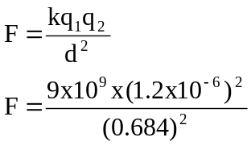
F = 2.77 x 10⁻² N repulsion

- If the two charges in question 5 touch, and the force between them is the same, how far apart are they now?
+1.2 μC +1.2 μC

+1.2+1.2
= 2.4 μC

+1.2 μC +1.2 μC
As the charges are the same value, there is no re-arrangement of charge so no change in force and the distance remains the same.

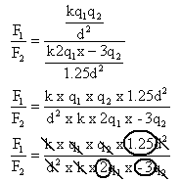
- Two metal coated table-tennis balls are charged identically and separated by a distance d in air. If the charge on one ball is doubled, the charge on the other tripled and reversed in sign, and the distance between them increased by 25%, how does the new electrostatic force compare to the old?

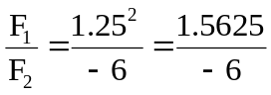

-6F₁ = 1.5625F₂
3.84F₁ = F₂
F₂ = 3.84F₁ in opposite direction (attraction)

